Application for financial support for the participation at ICTMA22 in Linköping, (10)11-15 August 2025 | 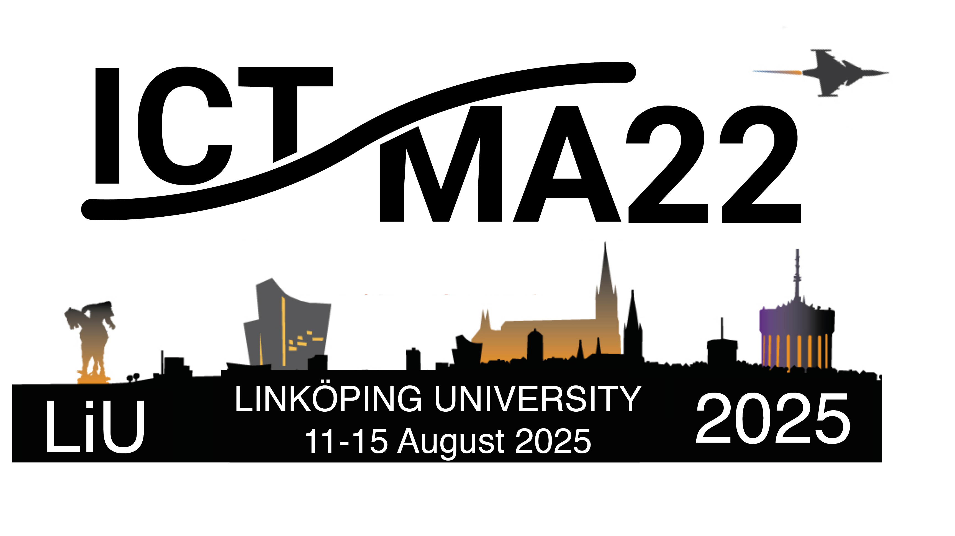

Family Name, First Name:
Title: |  | Year of Birth:
Nationality: |  | Country of Residence:
Affiliation / University Address:
Email Address:
Current Position: | (professor, PhD-Student, associate professor etc.)
☐ full-time-position ☐ half-time-position ☐ PhD-grant
☐ master student ☐ other position: ____________________
Submission(s) for ICTMA22 | Title:
 | ☐ poster ☐ short presentation ☐ long presentation
 | Co-authors:
Support from other ressources | For travelling to ICMTA22, I will receive _________ € support from my university / from the following other institution:
After having read the ICTMA22 support regulations, please state what it is about your circumstances that you feel makes your situation suitable for the support.

Please, send this form by email to ictma22@mai.liu.se
The strict deadline for the application is the 1st of June 2025.

