Welcome to Ryds Allé
Student accommodations by Heimstaden

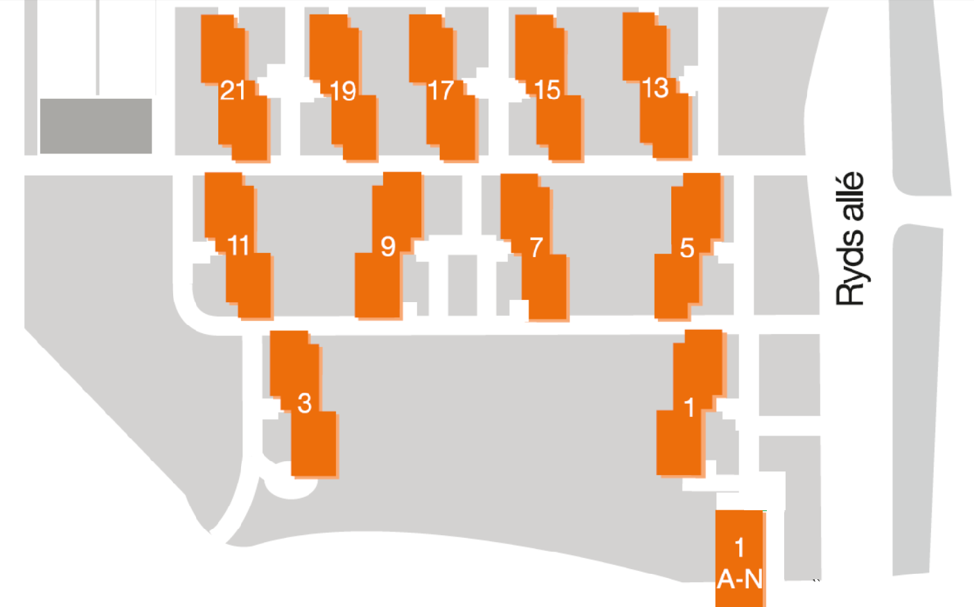

- Customer Service open 24/7 by calling + 46 (0) 770 111 050.
- Electricity, broadband, heating, water and furniture included in the rent.
- Washing powder and softener for free when using the laundry facilities.
- Sauna located in the basement of Ryds Allé 9 for free.

- Laundry rooms in the basement of Ryds Allé 9 and in the laundry house outside Ryds Allé 9.
- Recycling rooms located on the parking opposite Ryds Centrum.
- Use the green pillars outside the entrance to throw you household waste.
- Dionne is the cartaker at Ryds Allé. She will always do her best to make you comfortable while staying with us.

